**Assignment Module 5 –File Access and encoding**

1. Develop an application that uses file and directory access to encode their structure in a JSON file given a root directory. Create a python application that given a command-line argument of a root directory, it will traverse that directory and all subdirectories, saving into a file called struct.dat the JSON representation of the hierarchy of files and directory discovered. Use the following information to name file and directory in the JSON representation of the file/dir hierarchy,

“File”, “Dir”, “SubDir”

This file should be stored in the location that the program is executed and should override the file if it already exist.

import sys

import os

import json

x = os.walk(".")

d = {}

print("Walk's output:")

for thing in x:

print(thing)

x = os.walk(".")

for thing in x:

d[thing[0]] = (thing[1], thing[2])

print("Dict:")

print(d)

with open('struct.dat', 'w+') as f:

json.dump(d, f)

print("What’s in the file:")

print(json.dumps(d))

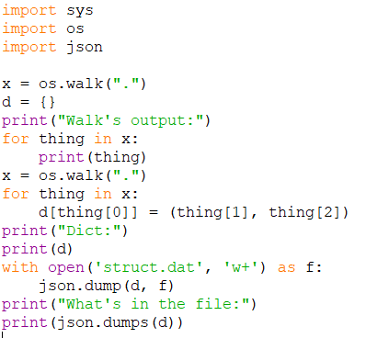

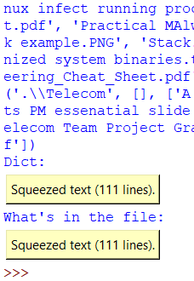

1. The program you created writes a JSON file. Is this a text or binary file? Discuss and justify why you would do it as a text file or a binary file. Justify, if done in binary, how would that work and what are the implications of saving the file and dir hierarchy as a binary file in saving and accessing it.

The program that I created creates a JSON text file. JSON is a web standard for a text file format therefore it is using a text file in my program above. This is easier because it is readable to human eye even if it contains lots of punctuation marks, data in the text file is organized and each word can be separated by comma, non-printable ASCII characters are not allowed, and whitespace is not important. If the file were to be in binary format, all above mentioned characteristics would fail without a software to read or write it. The byte sequence might get changed or the file might become corrupted if opened as a text file.